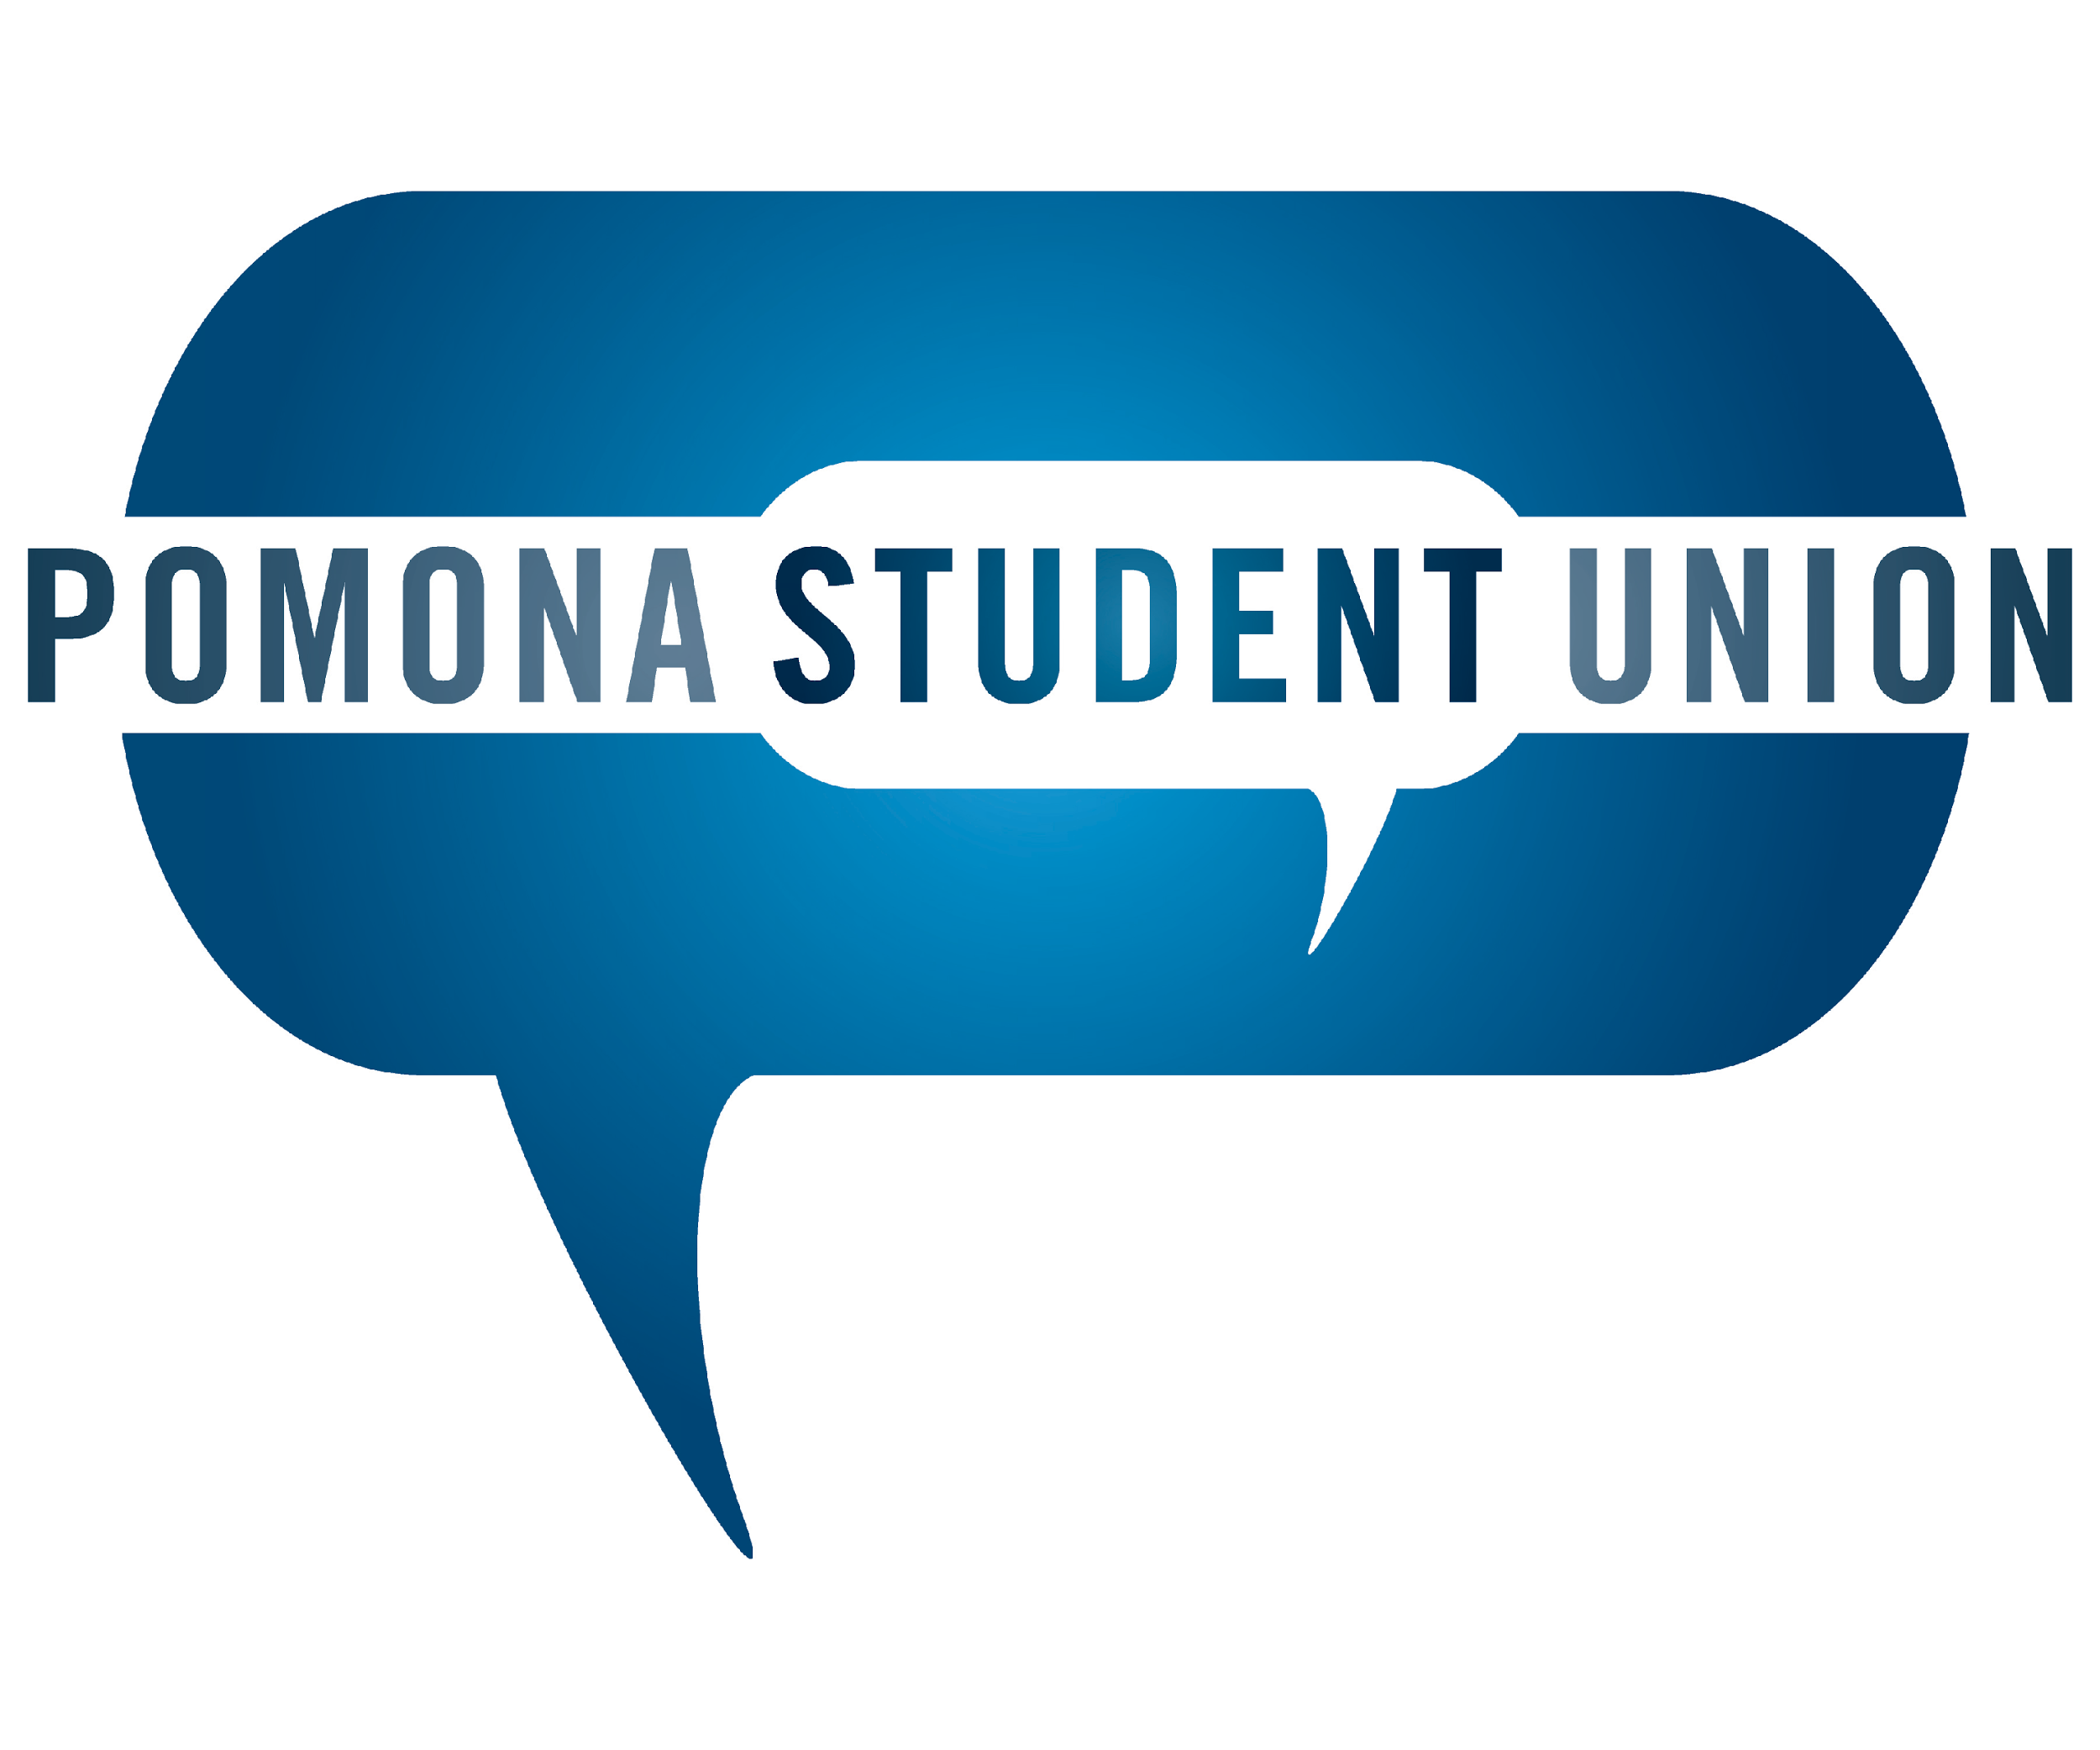
Name:
Email:
Year:
Hometown:
Intended Major:
Phone:

Our Mission Statement: The Pomona Student Union is a nonpartisan student-run organization committed to increasing the level of honest and open dialogue on campus; we challenge assumptions and present a multiplicity of perspectives through discussions, debates, and other mediums on important issues.

The PSU aims to better reflect the range of voices on campus and the perspectives missing from campus dialogue. We want to engage students on campus, challenge members of the campus community to relate to topics in new ways, and create productive, novel dialogue at the 5Cs. If you believe that particular voices and perspectives are missing on campus or from the PSU, we would love for you to apply!

The PSU does not discriminate on the basis of race, color, ethnic origin, national origin, creed, religion, political belief, sex, sexual orientation, gender identity or marital status.

We are interested in hearing about you and your experiences. Please keep your response under 300 words for each question. When finished, please return to psu@pomona.edu.

- What role do you think the PSU should play on campus and how will you help it achieve this role?

- Reflect on your experiences with dialogue on campus (in the classroom, with friends, etc.) and in other communities. How can the PSU best increase the level of critical dialogue, bring in new and nuanced perspectives, and challenge assumptions?

- What is one perspective that is missing in the communities you are/have been involved in? What do you think were the consequences of this missing perspective on the community?

- Write a brief outline of an event that you might plan as a PSU Board Member for the coming academic year, including potential speakers or the general perspectives you would insure were addressed. You should also briefly explain why this topic should be addressed on campus in the coming year and how it fits within the PSU mission statement.

PSU is a strong community, committed to supporting each other, investing in each other, growing together, and empowering each other and our larger community to promote diverse conversations on campus. It is a significant time commitment that has the potential to define a large part of your Pomona College experience. Keeping that in mind, please list any other activities or involvements you anticipate next year and explain what you imagine your involvement with PSU looking like.

List any other relevant abilities (graphic design, Tweeting master, etc.)

